Blue Team: Jonah Aney, Justin Marucci, Nardos Gabremedhin, Amanda Wedergren
Moffat Bay Island Marina Project

- Introduction
  - Purpose
This Technical Design Document establishes the requirements for the Moffat Bay Island Marina website, including technical and user requirements that support the desired user experience. Below are examples of typical users and their purposes, as well as terminology and work-time estimates to establish the project's general scope. The goal of the Moffat Bay Island Marina website is to provide users with access to the marina’s information, account sign-up, registration, and slip reservation, along with options to view the reservations and enroll in a waitlist.
  - Terminology
- Customer - A user who is registered with the website.
- Reservation - A saved docking space (slip) for a customer over a period of time.
- Slip - A specific amount of space intended to hold boats
- Slip Size - The length of space offered based on the options of 26, 40, and 50 feet.
- Wait list - System used to keep track of customers that want to reserve a specific size slip when reservations are full.
  - User Personas
      - 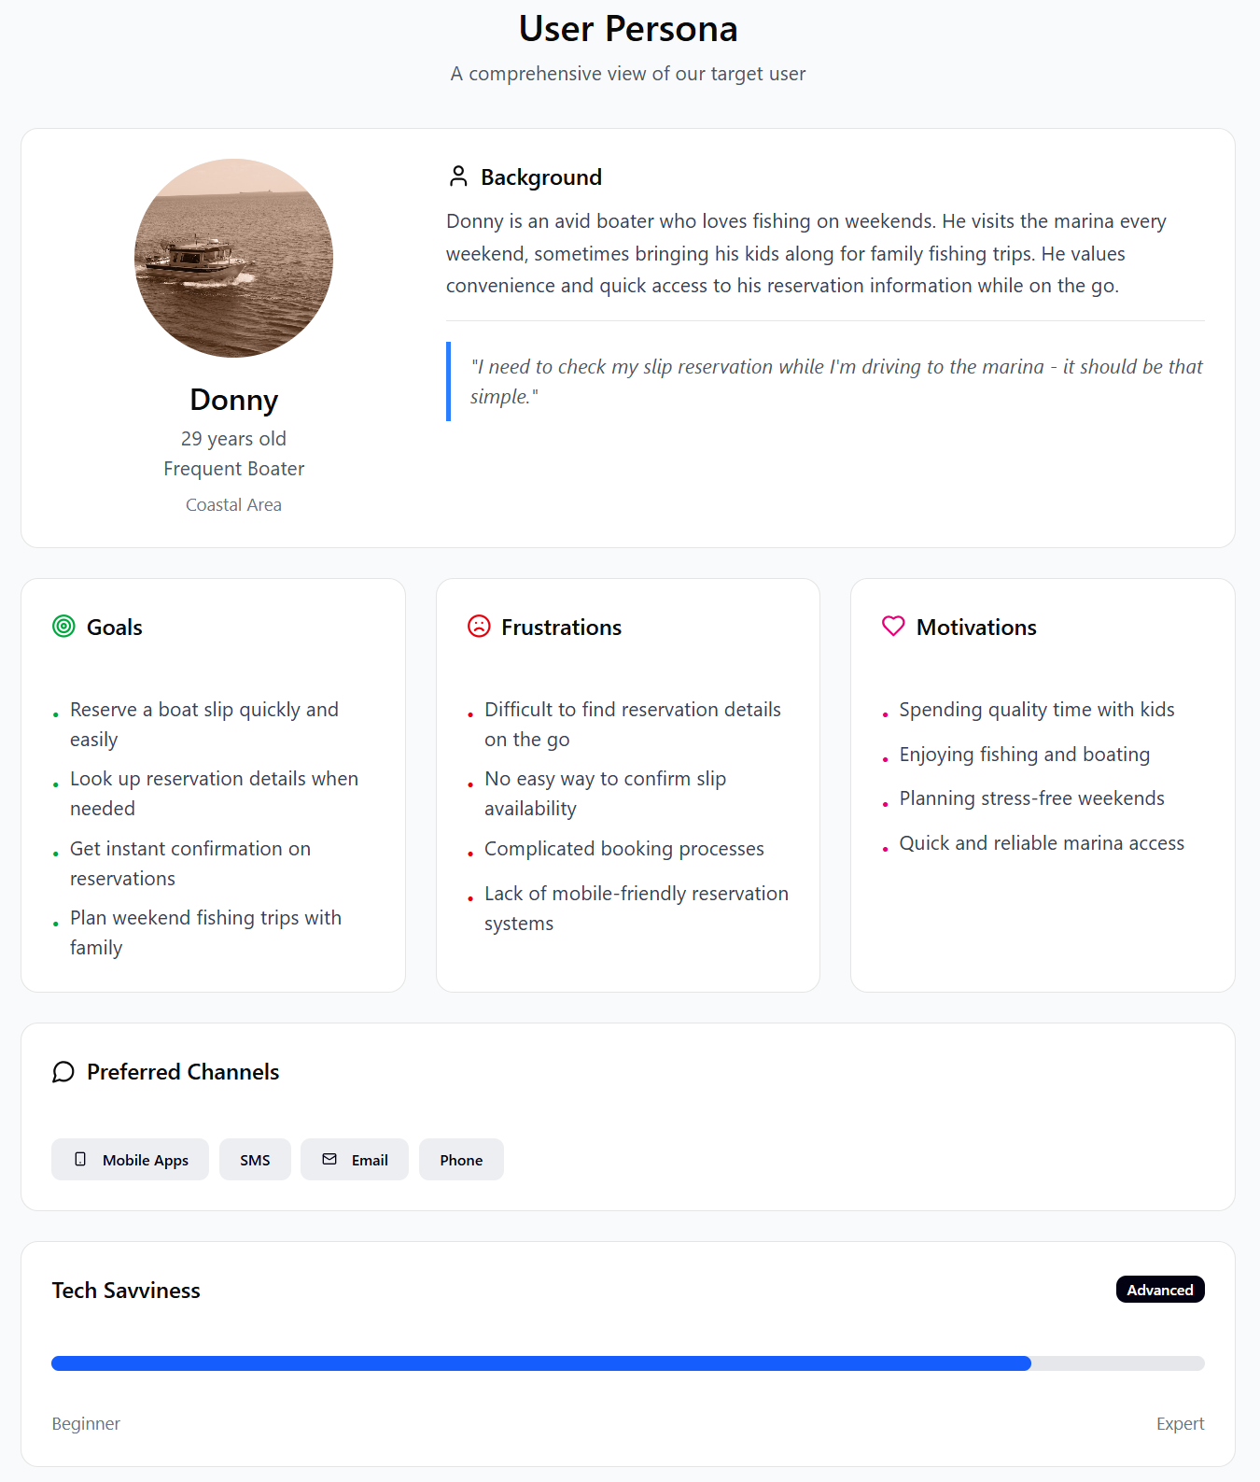
      - 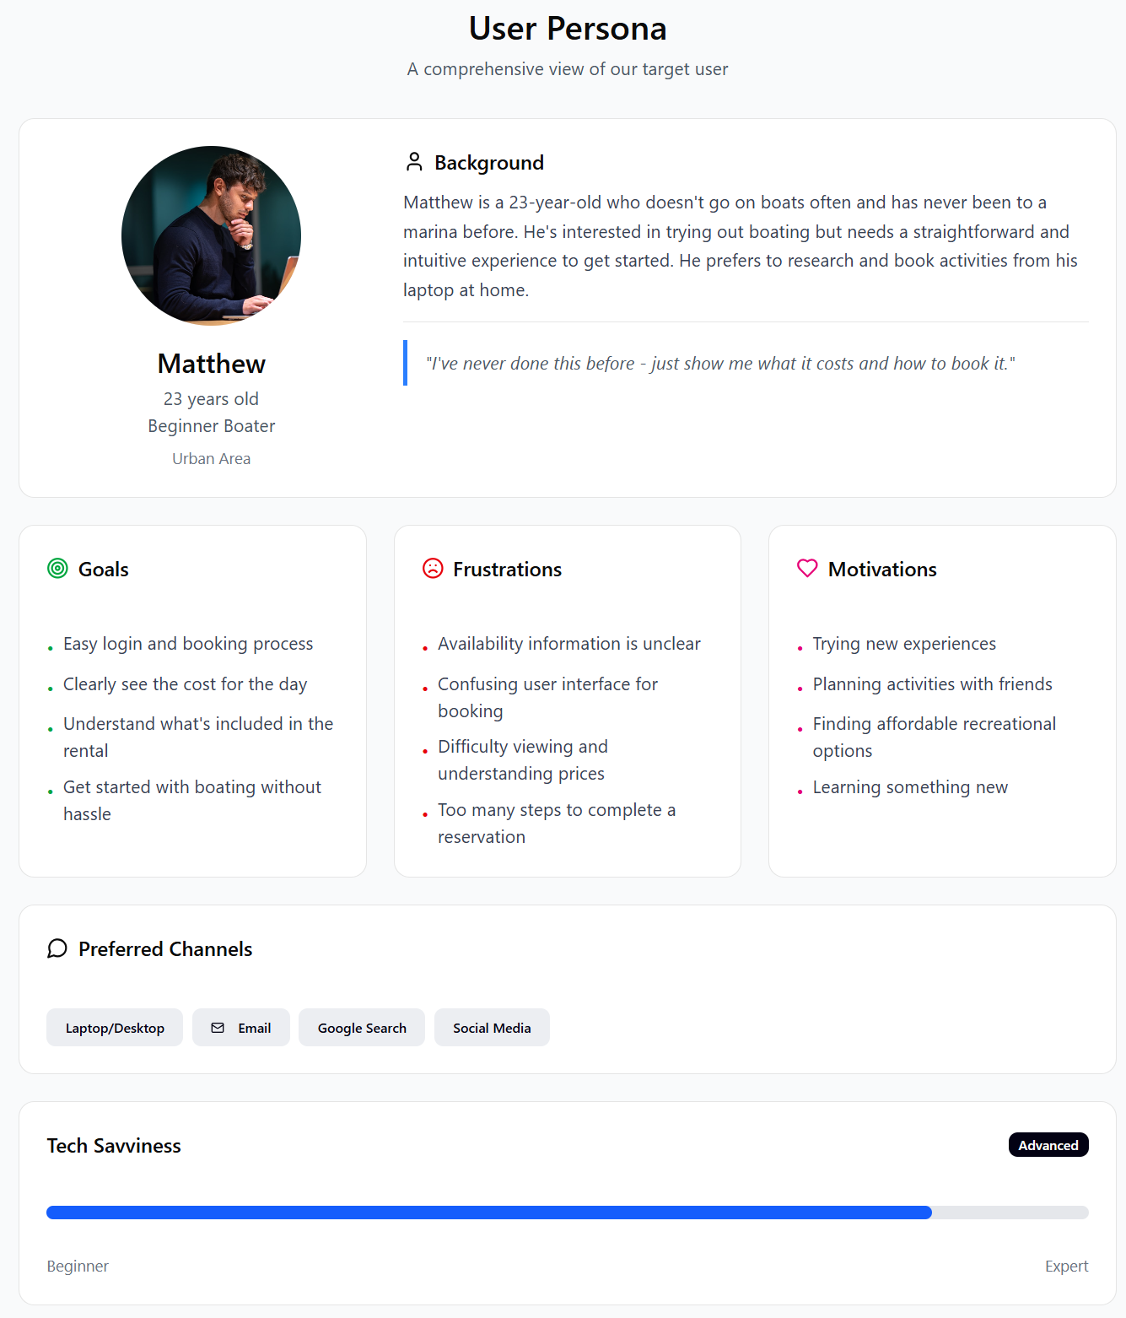
      - 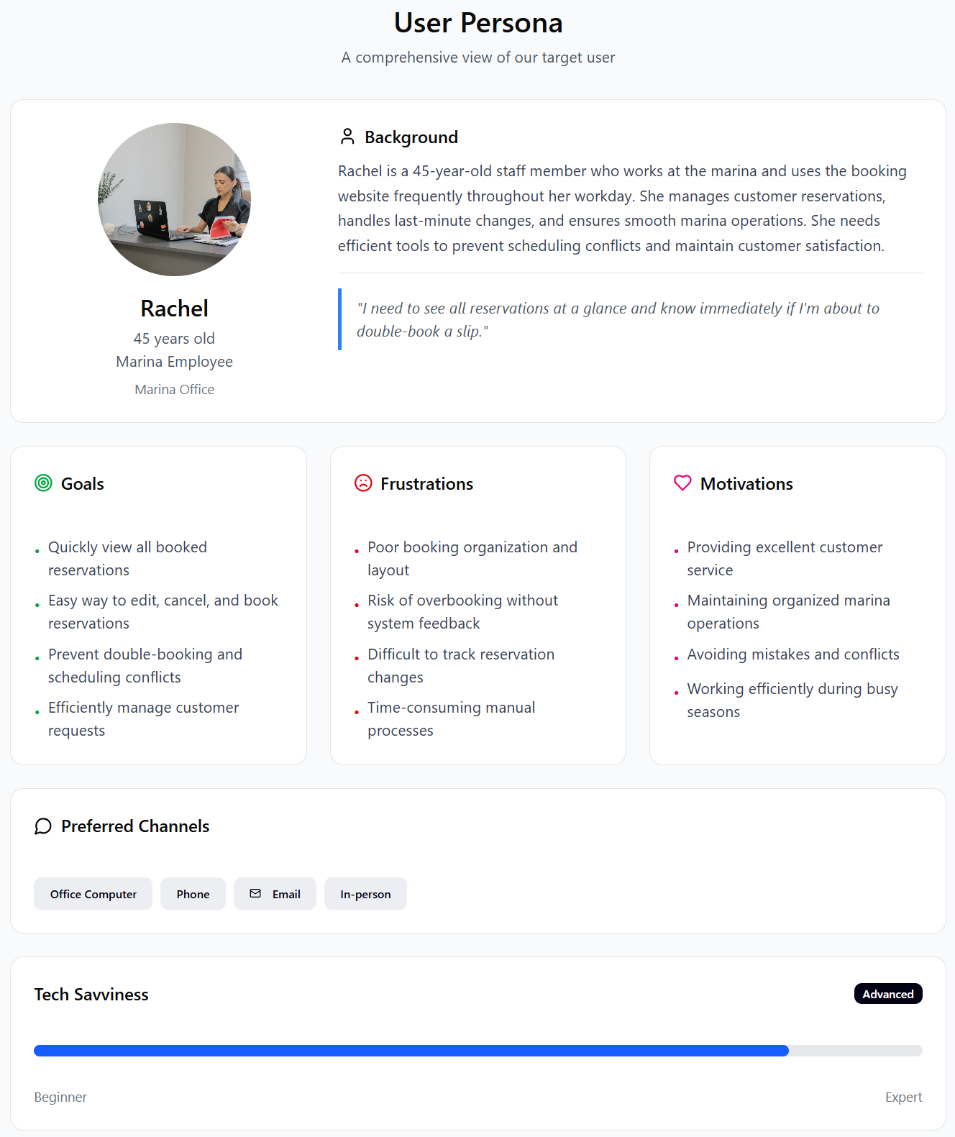
  - User Stories
      - Persona 1: Donny
        - As a customer, I want to reserve a marina slip from my computer so I can secure a spot before arriving to the marina.
        - As a customer I want to be able to look up reservation details or receive confirmation so that I know my slip is successfully booked and has all of the correct information
        - As a customer, I want to view a wait list so that I know when I can book a reservation if it is busy that day/week
      - Persona 2: Matthew
        - As a customer, I want the website/ user interface to be easy to navigate so I can make a reservation seamlessly
        - As a customer, I want to clearly see what slips are available for my selected date so I can confidently choose a reservation
        - As a customer, I want to see the total cost of the reservation so I understand how much I will be charged
      - Persona 3: Rachel
        - As an employee, I want to quickly view reservations for that day so I can manage booking operations efficiently
        - As an employee, I want to edit reservation details so that I can correct potential errors or accommodate customer changes
        - As an employee, I want to be able to book reservations on behalf of customers so I can assist walk-ins or phone reservations
  - Work Estimations (ToDo List)
 | Work Hours
As a customer, I want the website/ user interface to be easy to navigate so I can make a reservation seamlessly

Establish site structure as user navigation flow – how the user navigates from the main page to completing a reservation | 2
Confirm layout details for consistency on all pages - Headers/footers, fonts, colors, menu styles. | 2
Build pages using HTML and CSS - Main page, About page, Reservation Summary/Calendar page with payment options, Credit, debit, etc. | 7
Add site navigation elements - Menus and links on the pages for ease of use. | 3
Create a prompt for login/registration - Login is required for a reservation, so the user must register if they don’t have an account. | 2
Test the site for easy and correct page navigation - Correct and retest as needed. | 2
As a customer, I want to see the total cost of the reservation so I understand how much I will be charged

Set pricing - $10 per foot + $10 electric fee | 1
Add logic for cost calculation | 4
Have pricing available on the About page (slip reservation, electric fee, additional fees) and totaled at the end of the process on the summary page. | 3
Provide the customer with a confirmation message after the reservation is booked. | 2
Test the process with multiple boat sizes to ensure cost calculation accuracy. | 3
As an employee, I want to quickly view reservations for that day so I can manage booking operations efficiently

Create a database for the reservations - define the structure and the required fields | 4
Store customer data - reservation info: Name, contact, boat, slip size, date. | 3
Create a query for daily reservations - daily reservations can be easily retrieved by the employee. | 2
Create a table to display the daily reservations for employees - clear and easy to read/interpret. Sorted by time (earliest-latest). | 4
Provide the ability for reservation updates to be made and reflected in real-time. | 4
Run multiple tests and any edge cases - confirm retrieval, data organization, and/or updates are accurate. | 2
- Design
  - Prototypes
  - ERD
- QA Testing
  - QA Test Plan

